2019 – 2020 Treble Choir Information

Dear Treble Choir Students and Families,

Welcome to the Middle School Choir program! Contained in this packet of information, you will find a lot of information and expectations, a schedule, and the classroom grading syllabus. Please read this entire packet and keep it throughout the year because it answers a lot of questions!

REMIND – The application Remind is one of the most valuable communication tools used by the entire music department. It allows for fast communication to any type of cell phone and/or email account. I highly recommend enrolling right away to stay in the loop with choir. Instructions to join Remind are on the second to last page of this packet.

WEBSITE – Every student and parent should visit musicwams.weebly.com on a regular basis for the wealth of information that it provides.

Resources – This website will contain a copy of every handout and announcement the students receive in school, including this packet!

Song Recordings – The website will also contain recordings of most of the music we will be performing. Each student should spend time outside of rehearsal listening to these recordings to help learn their pitches and rhythms. The more that students engage in this listening, the easier it is to get to the fun part of rehearsing! Means of using song recordings to get bonus points in chorus will also be discussed at a later date.

SYLLABUS - The chorus ensemble is designed to be a fun place to learn music together. To ensure personal accountability in the student learning process, chorus is a graded class. Below, you will see the requirements that make up the entire chorus grade.

Participation – Given the nature of ensembles, active participation and responsibility are the main requirements for learning. For this reason, participation in rehearsals and concerts (see descriptions on next page) are 75% of a student’s grade. Each rehearsal will be graded as follows:

  - Attending Rehearsal On Time = 25%
  - Bringing All Required Materials = 25%
  - Following all rules of respectful ensemble behavior (contained on the Chorus Business bulletin board), and fully engaging in all aspects of the rehearsal = 50%

Projects – In order to dive deeper into music learning, students will be assigned projects throughout the year. These projects will range from a 2-minute music game during chorus rehearsal, to a quarterly take home assignment. All projects and due dates will be updated in PowerSchool before they are assigned in class, and large projects will be uploaded to musicwams.weebly.com. In total, these projects will count as 25% of a student’s grade.
REHEARSALS – Rehearsals during the school day are the main vehicle for learning in the music ensemble. They are a chance for us to develop together as musicians and create something together that we could never accomplish as individuals. On the next page, you will find a great deal more specific information about this keystone of chorus education.

Treble Choir (6th Grade) – Rehearsals for the Treble Choir will take place every Tuesday and Friday during the Tutorial Block. Prior to going to the Chorus Room (Room 203), members of the choir need to pack up and bring their belongings because they will not return to their lockers or homerooms before the end of the day. Singers are then required to be in their assigned seat no later than 1:45pm (4 minutes after tutorial begins) with all their chorus music and a pencil. Once in their seats, members of the choir will read the SmartBoard for further instructions.

Every Tuesday will be a FULL REHEARSAL with EVERY member of the Treble Choir. Fridays will usually be a sectional rehearsal with only part of the choir. However, a student should never assume they do not have rehearsal on a Friday. If a student is unsure whether or not they have rehearsal, they should check the whiteboard in the chorus room prior to that rehearsal, on Remind, or at musicwams.weebly.com.

*Everyone* - Each student will only participate in 1-2 fifty-five minute rehearsals per week, which means every minute of rehearsal time is precious. Requests to see other teachers will not be permitted unless approved by Mr. Stuart before the tutorial period begins. Students must follow the restroom policy discussed at the first rehearsal. Students should bring bottled water to rehearsal so that they do not need to use the water fountain.

Other Tutorial Activities – Any conflicts between Beginner Band, Concert Band, Jazz Band, and Bell Choir have been worked out between the WAMS Music Teachers, and students can participate in any or all music ensemble courses. In the case of other clubs/groups meeting during tutorial, student/parent communication with Mr. Stuart and the leader of the other club/group will increase the likelihood that the student can participate in both activities.

High School Auditorium Rehearsals – During the school day of each concert, we will have a 2 hour rehearsal at the High School (more information will be given later). In the days prior to Concert Day, students need to talk to their other academic teachers about the dress rehearsal and request upcoming work. All teachers are aware of this policy and students should have no issue with staying caught up in their other classes.

CONCERTS

Call/Performance – Members of both the Treble Choir and Concert Choir are required to arrive in the High School Chorus Room no later than 6:30PM on the evening of the concert. The performance will take place in the High School Auditorium at 7:00PM, and ending around 8:15PM. The Winter Concert Will take place on Monday, December 16th. The Spring Concert will take place on Tuesday, June 2nd.

Dress Code – Black and white are the only colors allowed to be worn by members of the Treble Choir and Concert Choir. White DRESS Shirts, Black DRESS Pants, Black Socks, and Black Shoes are ideal. However, girls may wear a Black Skirt or a Black and White color combination Dress. Black or white ties/bowties and black sport coats are also allowed, but not required. The Wallenpaupack Area School District Dress Code must be strictly followed, along with the concert dress code previously mentioned, or else the student will not be allowed to perform. If there is an issue in procuring the clothing articles listed, please contact Mr. Stuart ASAP.

Etiquette – An important part of music education is learning proper behavior at a formal concert. Therefore, the following rules of etiquette will be required of all students:
- Whether on stage or in the audience, students should never talk during a song.
- Entering or exiting the auditorium requires permission and should only be done during the applause between songs.
- On stage, students should NEVER talk, gesture toward the audience, or focus on anything other than their music, the task at hand, and the conductor.
- When in the audience, students should respectfully pay attention to the performing group and acknowledge the performance afterward with applause.

Eligibility – Students may not be eligible to participate in performances for the following reasons:
- The student is failing chorus
- Serious behavior issues during rehearsals
- Student is not adequately prepared to perform the music
- Student misses the dress rehearsal
- Student is absent from school on the date of the concert

Concert Absence – EVERY MEMBER OF THE CHOIR MATTERS! For this reason, an unexcused absence from a performance will result in the student’s semester chorus grade dropping by 10 percent.

However, there are life circumstances that warrant excusal from a Concert. If a foreseeable circumstance, such as the wedding of a family member, conflicts with the concert, an excuse may be granted by Mr. Stuart on a case-by-case basis if requested at least 2 weeks prior to the concert. In the event of an unforeseeable emergency, such as illness or family hospitalization, an excuse will be granted by Mr. Stuart if parental notification is given and the circumstances truly constitute an emergency.

Missed Concert Make-up – Students who are excused from a concert are required to complete and return a Missed Concert Assignment to Mr. Stuart within 1 week after returning to school or the absence will be treated as unexcused.

Academic Eligibility – Academic responsibility is an important factor in participating in music ensembles. Therefore, any student who receives 2 or more failing quarter grades within 1 academic year will no longer be eligible to participate in any vocal ensemble for the remainder of that school year.

Select Ensembles, Festivals, and Solos – In addition to the many performance opportunities available to the Treble and Concert Choirs, eligible students have the ability to seek out even more musical opportunities! Information regarding the Show Choir will be announced early in September. Auditions for the distinguished Middle Grades Music and Arts Festival and the PMEA District 9 Chorus Fest will take place in January. There will also be a number of solo opportunities throughout the school year. Students’ participation in these opportunities are contingent on having an A average in their current choir, and demonstrating positive behavioral choices.

A student’s IEP, 504, Health Concerns, and Safety Plan will be factored in how every chorus policy is implemented with individual students.

Sign up for important updates from Mr. Stuart.

Get information for Wallenpaupack Area Middle School right on your phone—not on handouts.

Pick a way to receive messages for Treble Choir:
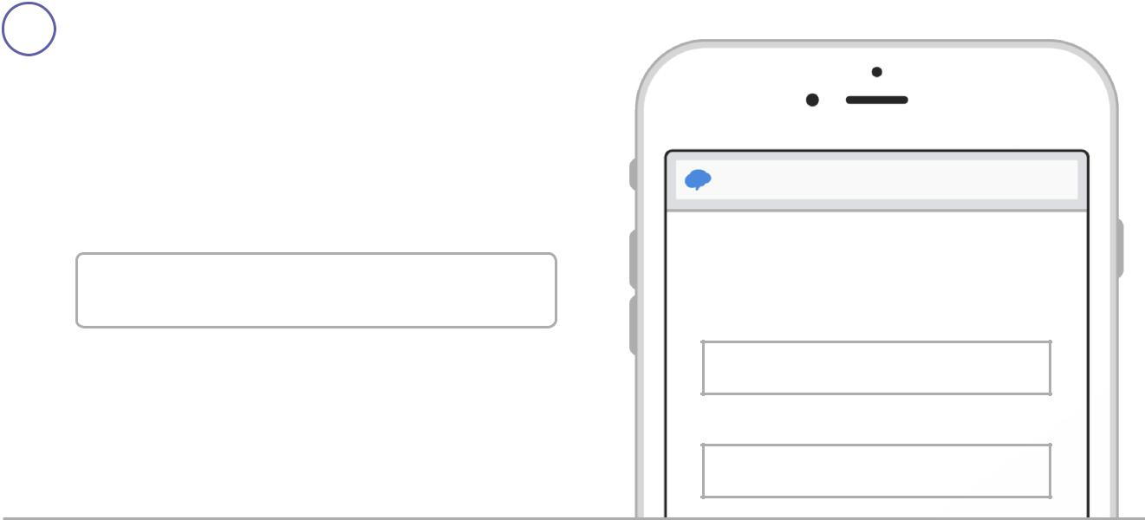

- If you have a smartphone, get push notifications.

On your iPhone or Android phone, open your web browser and go to the following link:

rmd.at/wamstchoir
Follow the instructions to sign up for Remind. You’ll be prompted to download the mobile app.

- If you don’t have a smartphone, get text notifications.

Text the message @wamstchoir to the number 81010.

If you’re having trouble with 81010, try texting @wamstchoir to (570) 291-5590.

* Standard text message rates apply.

Don’t have a mobile phone? Go to rmd.at/wamstchoir on a desktop computer to sign up for email notifications.

rmd.at/wamscchoir

Join Treble Choir

Full Name

First and Last Name

Phone Number or Email Address

(555) 555-5555

To

81010

Message

@wamstchoir
Important Dates

Below is a TENTATIVE list of events and deadlines for the 2019-2020 Choir Program. Any changes to the dates below will be announced in choir rehearsal and sent as a reminder to all parents who sign up for remind (instructions listed on page 5 of this packet). Also, all items in BOLD are MANDATORY.

Description | Date/Time | Additional Information
First Rehearsal and Informational Meeting | Friday, 9/6  DURING TUTORIAL | First tutorial rehearsal to go over what to expect from 2019-2020 Chorus Program.
Last day to sign up for a Show Choir Audition. | Friday, 9/20 | Separate information will be handed out to those interested during the first rehearsal.
Last Day for Schedule Changes | Monday, 9/30 | Last date for students to add/drop chorus. Students must turn in this form to add chorus by this date.
Veteran’s Day Assembly Performance | Monday, 11/11  During School | Chorus students will attend assembly SEPARATELY from classmates to perform.
Winter Concert HIGH SCHOOL Auditorium Rehearsal | Monday, 12/16  6th – 8:15AM | Rehearsal will take place during the school day. Students will report to the Choir Room immediately after homeroom. See section on High School Auditorium Rehearsals for more information.
*2019 Winter Choral Concert* | Monday, 12/16  Call – 6:30PM  Concert – 7:00PM | This concert is MANDATORY for all choir students. See the section on Concerts for more information.
PMEA Chorus Fest and Middle Grades Festival Auditions | January 8th, 9th, and 10th | Sign-ups and audition information will be given before Winter Break.
Spring Concert HIGH SCHOOL Auditorium Rehearsal | Tuesday, 6/2  6th – 12:30PM | Rehearsal will take place during the school day at the high school. See section on High School Auditorium Rehearsals for more information. Students will be dismissed from the high school at the end of this rehearsal.
*2020 Spring Choral Concert* | Tuesday, 6/2  Call – 6:30PM  Concert – 7:00PM | This concert is MANDATORY for all choir students. See the section on Concerts for more information.
Last Day to Sign Up or Opt-Out for 2020-2021 Concert Choir | Friday, 6/5 | 6th/7th grade students will be given sign-up or opt-out sheets 2 weeks prior to the deadline.
Optional Performance at SWB Penguins Game | Friday, 1/10 | More information will be given out regarding this optional performance.
Optional Performance at SWB Railriders Game | TBA | More information will be given out regarding this optional performance.
Optional Trip to Kalahari for the PMEA All-State Music Festival | TBA | More information will be given out regarding this optional performance.

